Step 1
Log Into Canvas: dcps.instructure.com Step 2
Username: StudentID@students.k12.dc.us
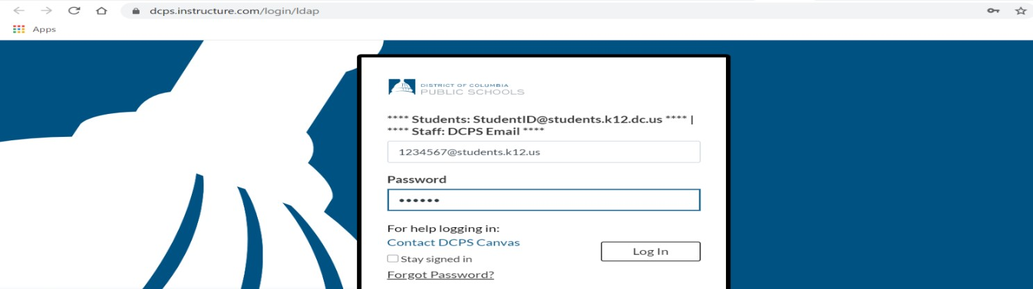
Password: Birthday in 6 digit form. For example Jan 12, 2013 is 011213

Step 3
Click Log In and enter your homeroom class

Students can also log in through www.clever.com
Enter Student ID and Password
Click “Login Canvas”

